Name________________________________ Date____________________

Document Based Question Essay

Historical Context:

The histories of Greece and Rome have seen the rise and fall of governments that ushered in eras of commerce, artistic achievement, and scientific advancement. In Greece, the governments of Athens, Sparta, and Macedonia held power at different times, and in Italy, the Roman Republic and Roman Empire controlled the Mediterranean Sea region.

Task: Using information from the documents below and your knowledge of social studies, answer
the questions that follow each document in Part A. Your answers to the questions will help
you write the Part B essay, in which you will be asked to
For both Greek and Roman governments mentioned in the historical context
- Discuss how the governments controlled their citizens
- Explain how this control led to positive and negative impacts

In developing your answers to Part III, be sure to keep these general definitions in mind:

(a) explain means “to make plain or understandable; to give reasons for or causes of; to show the logical development or relationships of”

(b) discuss means “to make observations about something using facts, reasoning, and argument; to present in some detail”

Part A
Short Answer Questions

Directions: Analyze the documents and answer the short-answer questions that follow each document in the
space provided.

Document 1
Athenian and Spartan Areas of Control

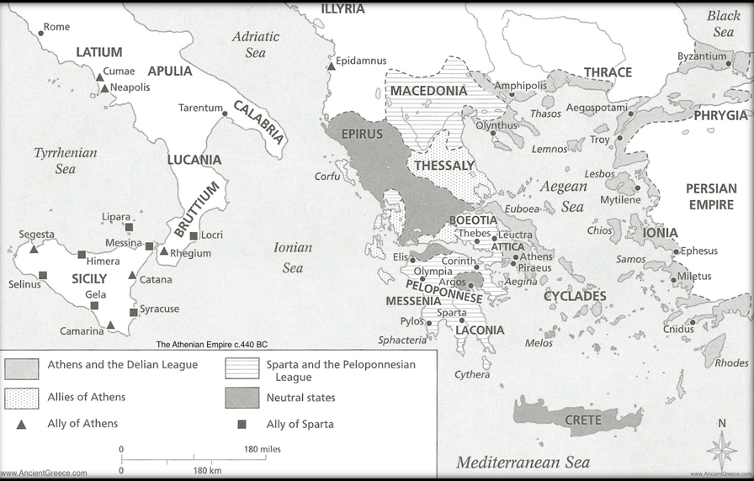
Source: “Athenian Empire’. University Press Inc, 2012 (http://www.ancientgreece.com/media/img/athenian_empire.png)

Based on the map above, how did the city-states of Athens and Sparta control citizens of Greece beyond their own territory?

______________________________________________________________________________________________________________________________________________________________________________
_______________________________________________________________________________________

How could this control lead to positive impacts?

______________________________________________________________________________________________________________________________________________________________________________
_______________________________________________________________________________________

How could this control lead to negative impacts?

_____________________________________________________________________________________________________________________________________________________________________________________________________________________________________________________________________
Document 2

Over the centuries, one of the mainland city-states rose to become the most prosperous and powerful in all of Greece. This city-state was Athens. Athens was small by modern standards - it covered just 1,000 square miles…
Athens was a direct democracy. All adult male citizens voted for or against suggested laws in the assembly. This was the first known democratic government in history.
The Athenians had a high regard for learning, the arts, and literature. The Greeks stressed loyalty to their city-state, but the Athenians valued the individual above the group. The Athenians stressed individual thought and action. “Know thyself” was a Greek motto. Students spent much time in the study of music, arithmetic, literature, and writing. The Athenians also stressed physical fitness for men. Their goal was “a sound mind and a healthy body”…
Pericles was the leader of the strongest Athenian political party. He was also the commanding general of all the military forces of Athens. Pericles led Athens for many years – from 460 to 429 BC. During this time, known as the Age of Pericles, Athens entered a golden age of the arts and philosophy.

Source: Henry Abraham and Irwin Pfeffer. Enjoying Global History. Amsco School Publications (2006)

Based on the excerpt above, how did Athens control its citizens?

_____________________________________________________________________________________________________________________________________________________________________________________________________________________________________________________________________

How did this control lead to positive impacts?

_____________________________________________________________________________________________________________________________________________________________________________________________________________________________________________________________________

Document 3

The Spartan government was founded on the principle that the life of every individual, from the moment of birth, belonged absolutely to the state. The elders of the city-state inspected the newborn infants and ordered the weak and unhealthy ones to be carried to a nearby chasm and left to die. By this practice Sparta hoped to ensure that only those who were physically fit would survive.
The children who were allowed to live were brought up under a severe discipline. At the age of 7, boys were removed from their parents' control and organized into small bands. The strongest and most courageous youths were made captains. The boys slept in dormitories on hard beds of rushes. They ate black broth and other coarse food. They wore the simplest and scantiest clothing. Unlike the boys of Athens, they spent little time learning music and literature. Instead they were drilled each day in gymnastics and military exercises. They were taught that retreat or surrender in battle was disgraceful. They learned to endure pain and hardship without complaint and to obey orders absolutely and without question…
…The Spartan armies, though usually quite small, were well-disciplined and all but irresistible in combat. Each citizen soldier was inspired by the resolve to win or die. The Spartan mother, when she gave her son his shield, would say: "Bring back this shield yourself or be brought back upon it," referring to the manner in which the dead were carried on their shields from the battlefield. Among Sparta's most heroic achievements was the stand taken by its fighting men at the battle of Thermopylae in 480 BC, during the Persian Wars…
Sparta's prowess naturally brought rivalry with Athens, the leader of the northern states and for a time of all Greece. This rivalry culminated in the Peloponnesian War (431-404 BC), which resulted in Athens' ruin and Sparta's supremacy…But the tyranny of the Spartans aroused hatred and rebellion among those who had been conquered, and the jealous limitations on citizenship gradually reduced the number of specially trained warriors until only a few hundred remained. After about 30 years of Spartan domination, the Thebans under Epaminondas defeated Sparta in 371 BC and ended its power.
The long war with Athens had weakened many of the city-states. Their weakness and disunity left them prey to a greater power that was emerging in the north--Macedonia and its King Philip II [father of Alexander the Great]. He came to the throne in 359 BC, and within a year he was already waging a war of expansion. By 339 he had achieved control of Greece, including Sparta. In the 2nd century BC Sparta was absorbed by Rome's legions.

Source: Dr. Robert A. Guisepi “Sparta”. International World History Project, 2001. (http://history-world.org/sparta.htm)

Based on the excerpt above, how did Sparta control its citizens?

_____________________________________________________________________________________________________________________________________________________________________________________________________________________________________________________________________

How did this control lead to negative impacts?

_____________________________________________________________________________________________________________________________________________________________________________________________________________________________________________________________________

Document 4

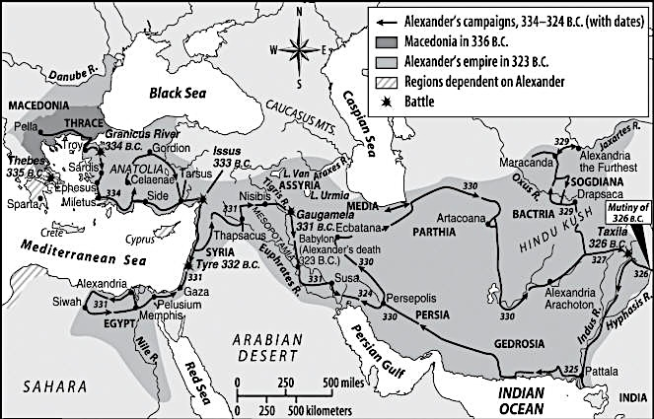

Source: http://web.cocc.edu/cagatucci/classes/hum213/Maps/AlexanderCampaigns20574.jpg

Based on the map above, how did Alexander the Great control people in Greece, Egypt, Persia, and India?

_____________________________________________________________________________________________________________________________________________________________________________________________________________________________________________________________________

How could this control lead to positive impacts?

______________________________________________________________________________________________________________________________________________________________________________
_______________________________________________________________________________________

How could this control lead to negative impacts?

_____________________________________________________________________________________________________________________________________________________________________________________________________________________________________________________________________

Document 5

The Twelve Tables were written in the mid 5th century BCE. These laws (carved into twelve stone tablets) regulated agriculture, trade, marriage, property and inheritance rights, and the legal rights of those accused of a crime and suing others in court. They served as a basis for Roman law during the next thousand years.
Table I
I. If anyone summons a man before the magistrate, he must go. If the man summoned does not go, let the one summoning him call the bystanders to witness and then take him by force.

Table III
I. Thirty days shall be allowed by law for payment of confessed debt and for settlement of matters adjudged in court

Table IV
I. A dreadfully deformed child shall be quickly killed

Table VIII
XII. If a thief commits a theft by night, if the owner kills the thief, the thief shall be killed lawfully

XIII. It is unlawful for a thief to be killed by day....unless he defends himself with a weapon; even though he has come with a weapon, unless he shall use the weapon and fight back, you shall not kill him. And even if he resists, first call out so that someone may hear and come up.

XXIII. A person who had been found guilty of giving false witness shall be hurled down from the Tarpeian Rock.

Table IX
VI. Putting to death of any man unconvicted [not guilty] is forbidden.

Table XI
II. Marriages shall not take place between plebeians and patricians.
Source: Oliver J. Thatcher, ed., The Library of Original Sources (Milwaukee: University Research Extension Co., 1901), Vol. III: The Roman World, pp. 9-11.

Based on the laws from the Twelve Tables above, how did the Roman Republic control its citizens?

_____________________________________________________________________________________________________________________________________________________________________________________________________________________________________________________________________

How did this control lead to positive impacts?

_____________________________________________________________________________________________________________________________________________________________________________________________________________________________________________________________________

Document 6

Roman Trade Routes

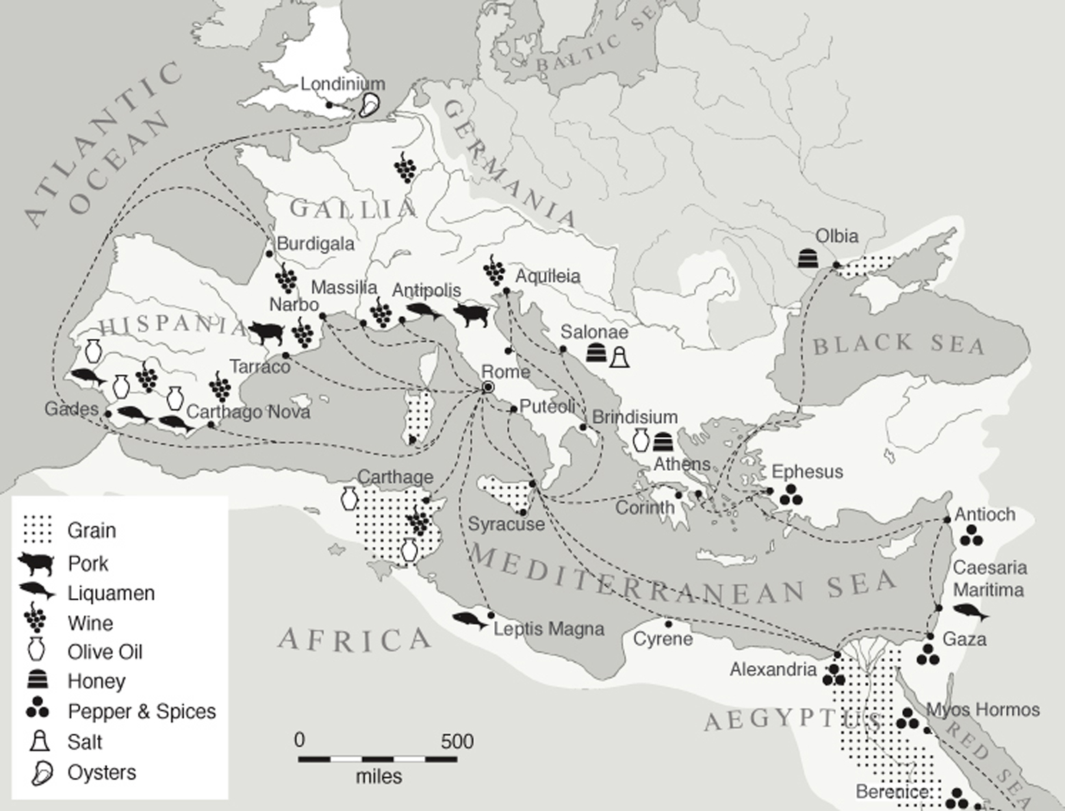
Source: Bettery Magazine (http://betterymagazine.com/wp-content/uploads/2013/07/Rome-map-ancient-food-miles-photo-A-Hungry-City.jpg)

Based on the map of Roman trade, how did the Roman Republic control people beyond Italy?

______________________________________________________________________________________________________________________________________________________________________________
_______________________________________________________________________________________

How could this control lead to positive impacts?

______________________________________________________________________________________________________________________________________________________________________________
_______________________________________________________________________________________

How could this control lead to negative impacts?

______________________________________________________________________________________________________________________________________________________________________________
_______________________________________________________________________________________
Document 7
The new order of building spread rapidly across the empire as an embodiment of Roman strength and leadership. Soon every major provincial capital had its basilicas, its roofed baths, its monumental arches, its paved roads, and often its aqueducts too. The Romans also inspired their allies to emulate them. When Herod the Great of Judaea determined to found a new seaport on the barren coast of Palestine, […] he decided to show his friend Augustus that he, too, could build a city on the Roman scale. Enormous blocks of limestone, fifty feet long, were lowered into twenty fathoms of water, to provide a sea wall. The new city’s public buildings included a theatre, an amphitheatre, and a hippodrome; aqueducts brought water from a distant river; there was a large and complex drainage system operated by tidal power…
…The Mediterranean [Sea] had become a Roman sea, its shores white with Roman temples and crowded with Roman municipia [cities]. Roman ships patrolled the Atlantic and roamed the Black Sea. Since all roads ended in Rome, the Romans were able to buy silk from China, spices from the East Indies, perfume from Arabia, glassware from Tyre and Sidon, marble from Greece, porphyry from Egypt, tin from Britain and Spain, and furs from the far north. Epicures [food lovers] had their choice of figs and dates from Syria, tunny from the Black Sea, oysters from Britain, and sausages from Gaul.

Source: Robert Payne. Ancient Rome. New York: J. Boylston and Company, 2005

Based on this excerpt, how did the Roman Empire control people beyond the city of Rome?

_____________________________________________________________________________________________________________________________________________________________________________________________________________________________________________________________________

How did this stability lead to positive effects?

_____________________________________________________________________________________________________________________________________________________________________________________________________________________________________________________________________

Part B
Essay
Directions: Write a well-organized essay that includes an introduction, several paragraphs, and a
conclusion. Use evidence from at least four documents in the body of the essay. Support your
response with relevant facts, examples, and details. Include additional outside information.

Historical Context:

The histories of Greece and Rome have seen the rise and fall of governments that ushered in eras of commerce, artistic achievement, and scientific advancement. In Greece, the governments of Athens, Sparta, and Macedonia held power at different times, and in Italy, the Roman Republic and Roman Empire controlled the Mediterranean Sea region.

Task: Using information from the documents below and your knowledge of social studies, answer
the questions that follow each document in Part A. Your answers to the questions will help
you write the Part B essay, in which you will be asked to
For both Greek and Roman governments mentioned in the historical context
- Discuss how the governments controlled their citizens
- Explain how this control led to positive and negative impacts

Guidelines

In your essay, be sure to
- Develop all aspects of the task
- Incorporate information from at least four documents
- Incorporate relevant outside information
- Support the theme with relevant facts, examples, and details
- Use a logical and clear plan of organization, including an introduction and a conclusion that are beyond a restatement of the theme

